**Steps for building web servers using EC2 AWS ----**

Step 1: Login in AWS management console.

Step 2: Go to the Services >> Compute >> EC2.

Step 3: Go to the instance >> Launch Instance.

Step 4: Create Instance by filling details like

* Instance name,
* **Amazon Machine Image (select Windows)**,
* Key pair (login)

{create new key pair >> Key pair name >> Private key file format as .pem >> create key pair}.

* A key pair file will be downloaded.

Step 5: Keep remaining settings as it is then click on Launch Instance in right panel of the Window.

Your Instance is created.

Now go the Instances , select your instance then click on connect.

Step 6: You will be forwarded to Connect to instance.

* Select RDP client >> Download remote desktop file >> Get Password.
* Upload private key file >> select that key pair file here >> decrypt password.
* Copy the password.

Step 7: Open Remote desktop file and enter that copied password.

Now your virtual machine is ready to use.

After opening Virtual Machine then follow below steps in it….

Step 8: Firstly, Off The windows defender and firewall….

Then Download the Apache server from web browser @ [Apache VS17 binaries and modules download (apachelounge.com)](https://www.apachelounge.com/download/).

And put that server file in c drive.

Now we have to open httpd file from bin inside Apache24 i.e. C:\Apache24\bin .

Step 9: Open CMD then put address to bin file by command i.e. C:\Users\Administrator>cd C:\Apache24\bin

C:\Apache24\bin>httpd -k install

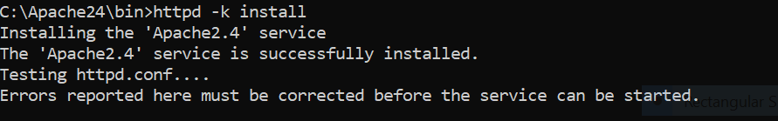

Now Server is installed.

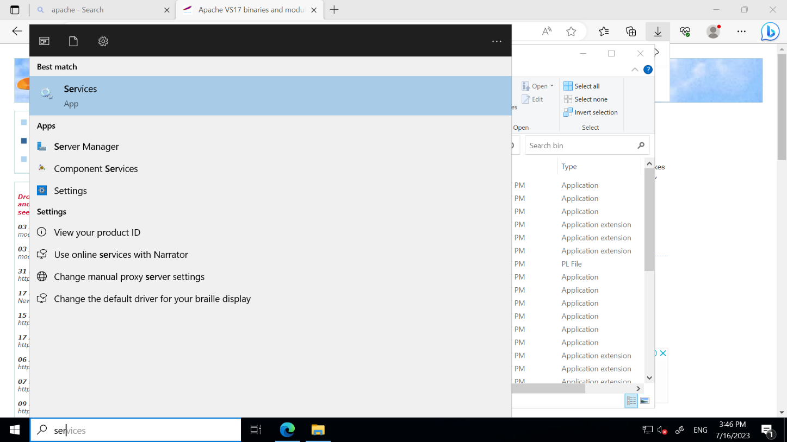Step 10: Open services.



Now start Apache server.

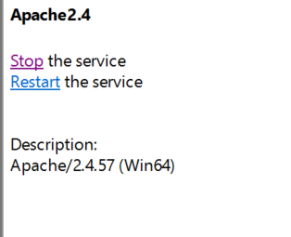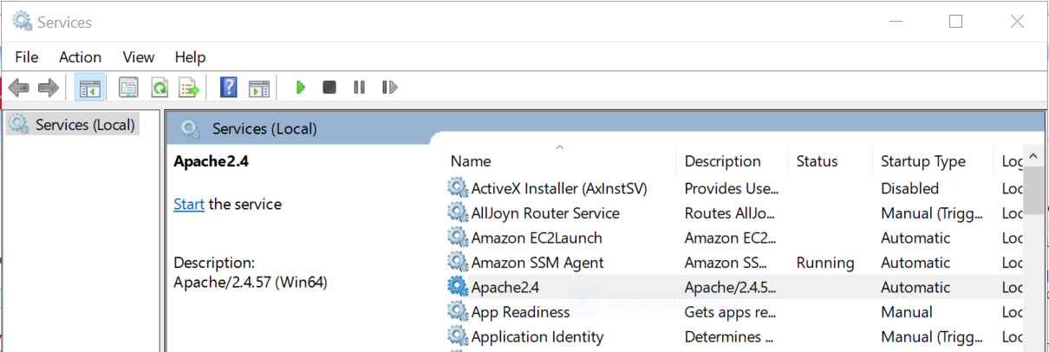

Step 11: Now Open browser and enter 127.0.0.1 or localhost.

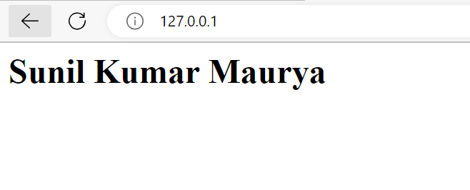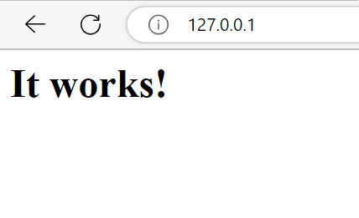

**\*\*\*If you want to edit the localhost page go to htdocs i.e. C:\Apache24\htdocs and edit index file.**